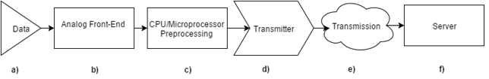

Figure 1. System Block Diagrams which shows each component of the complete system

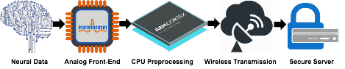

Figure 1b. Graphic System Block Diagram

Figure 2. nRF52 memory map.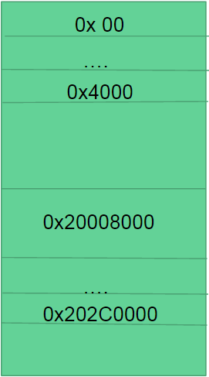

ROM: 0x0 - 0x4000, RAM: 0x20008000 - 0x202C0000

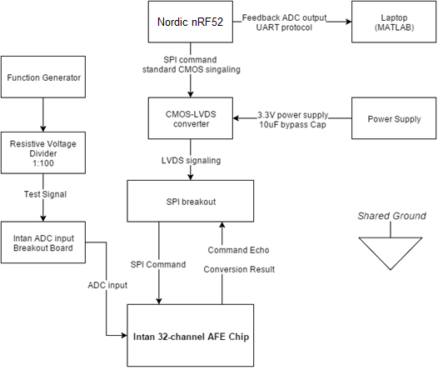

Figure 3. Complete System Setup for configuration and testing of Intan RHD2132 Analog-Front-End Chip

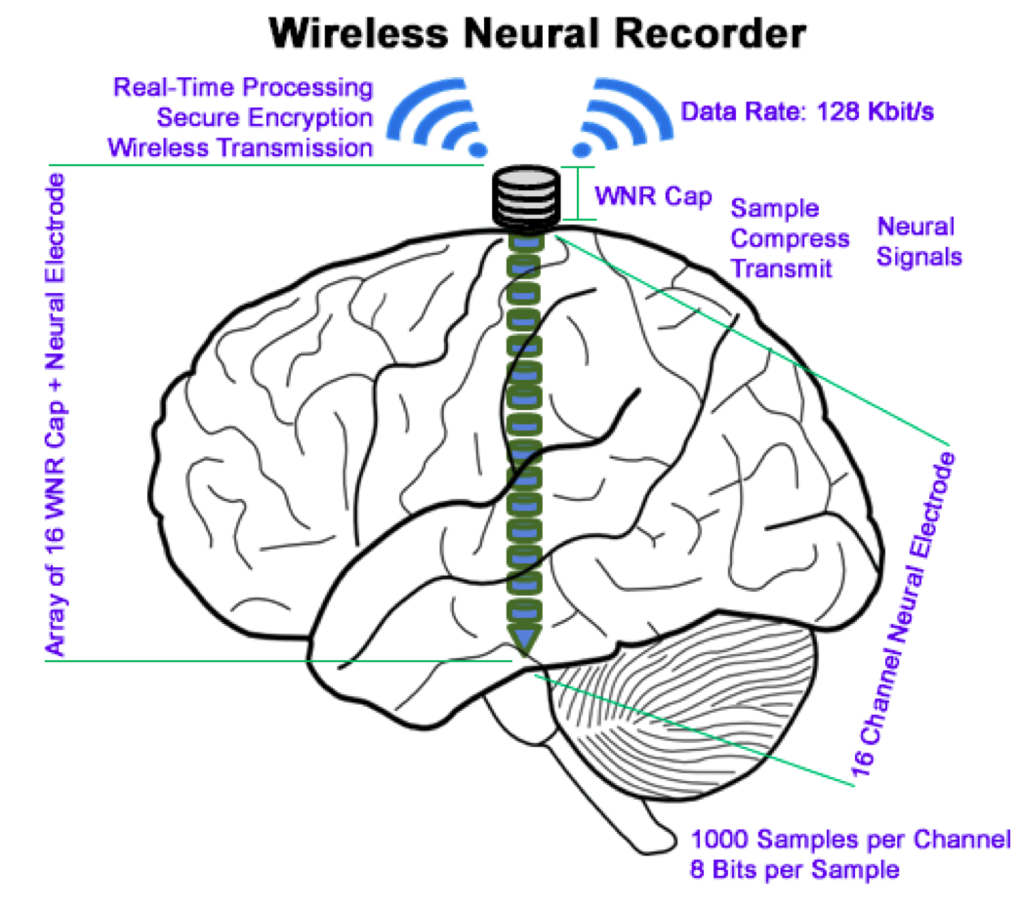

Figure 4. System Usage and Specifications

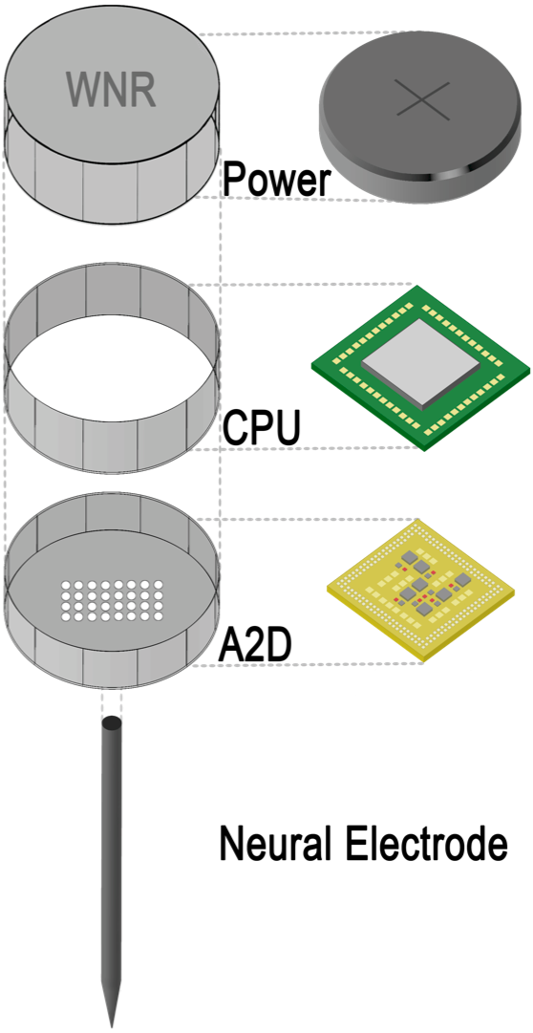

Figure 5. Expanded view of single WNR cap on neural electrode

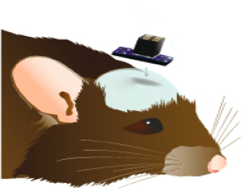

Figure 6. Small animal testing

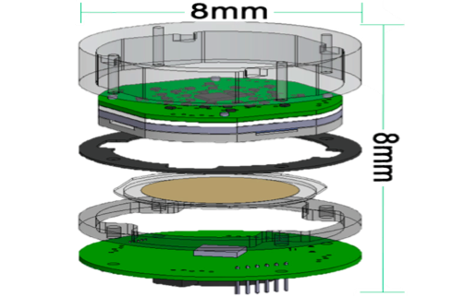

Figure 7. Future WNR Prototype